Proposed Dechannelization of a Segment of the Hoosic River in North Adams:

The First Step Towards Restoration

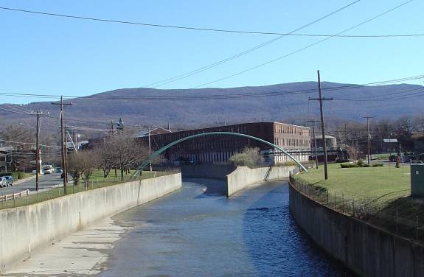

(Courtesy Jim MacBroom P.E.)

Prepared by Elena Traister

Yale School of Forestry and Environmental Studies

Revised June, 2004

Introduction

The Hoosic River has its headwaters in Massachusetts’s northern Berkshire County (see Figure 1). The South Branch of the Hoosic River (flowing north from the town of Cheshire) meets the North Branch (flowing south from the town of Clarksburg and Vermont) in North Adams. From the confluence, it flows northwest through the Town of Wiliamstown into Vermont. It continues into New York State, where it joins the Hudson River. According to the USGS, the Hoosic River drains 205 square miles before crossing the Massachusetts state line (1974).
The Hoosic River Basin in Massachusetts is varied in land use (Figure 2). In the City of North Adams and the Town of Adams, the river is constrained by commercial and residential development. Historic mill buildings that used to house textile and electric industries line the Hoosic River. Elsewhere in the basin, agricultural lands are found in the river valley, while the uplands remain forested.
The Hoosic River was seriously impacted by the unregulated actions of these old mills, which were in operation mainly before the Clean Water Act provided a measure of protection for natural waters. The Berkshire Regional Planning Commission (BRPC) documents a time when pollution caused the river to exude foul odors (1986), and residents of these towns remember when the color of the river changed on a daily basis. While water quality in the river has dramatically improved since that time, Mass. DEP still documents “elevated levels of some contaminants (PCBs, PAHs, TOC, metals including Cu, Pb, Ni, Zn, and organochlorine pesticides). (2000)”
Large floods in the 1930’s and 1940’s led to the construction of separate Federal Flood Control Projects in both Adams and North Adams. These projects include a total of 4.4 miles of channelization in Adams and North Adams (Mass. DEP, 2000). According to FEMA, the engineered channel in North Adams was designed to carry the 500-year-flood (1981).

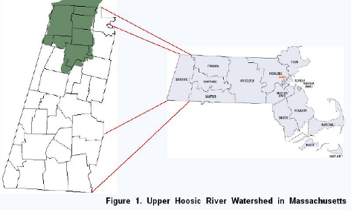
(Maps from US Census and MassGIS)

While the flood control projects have successfully prevented flooding in Adams and North Adams, they have done so at great ecological, recreational, and aesthetic cost. Property values along the concrete channel are significantly lower than they would be if the flood control project had employed a more natural design. And while the projects have been successful in providing protecting the towns from flooding, they will not last forever. The Army Corps of Engineers originally estimated that the lifespan of the chutes would be approximately 50 years. Although a section of a floodwall collapsed in North Adams, and cracks in the walls and bottom of the structure have been addressed in Adams, the project is still considered to be structurally sound. Since it is clear that the flood control chutes require work in the future as the structures continue to age, the City of North Adams should follow the example of the Town of Adams, which is pursuing a more natural flood control design to improve ecological function and public access to this valuable natural resource.
Due to the channelization, Mass. DEP has assessed the entire 4.4 miles of the flood control chutes as “non-support” with respect to “Aquatic Life Use” (2000). Water is significantly warmer in the flood control chutes, due to dramatically reduced water depth, poor aeration, and lacking overhead cover. These conditions are inhospitable to fish, while the smooth surface prohibits plant and macroinvertebrate growth necessary for any functioning aquatic habitat. This impact is particularly unfortunate in the upper Hoosic River, which is one of the few cold-water rivers in Massachusetts containing populations of native brook trout and naturally reproducing brown trout. A healthy population of trout is not only an ecological benefit, but also an economic advantage, attracting anglers to a region heavily dependent on tourism. The flood control chutes severely limit this habitat.
The City of North Adams is undergoing a slow revitalization, with growth in the areas of technology, recreation, and the arts. With structural maintenance of the Hoosic flood control project a future concern, North Adams should consider creative ways to include a more accessible river in its new image. According to the BRPC:

During the time of industrial growth, residents abused the river. Now they ignore it. Yet the river is far cleaner and more attractive than it used to be. While considering ways for tourism to take up the slack of lost industrial jobs, Northern Berkshire could benefit from attending to this exciting and potentially useful resource. (1986)

North Adams and Adams have a choice in how they want to engineer the Hoosic River in order to guard against flooding while at the same time restoring its recreational and ecological value. Adams has already initiated a habitat restoration project aimed at enhancing trout habitat in the channelized section of the Hoosic running through downtown Adams. Flood control projects are increasingly incorporating natural designs that promote aquatic habitat and public access. Some projects are so successful in replicating a natural channel that they are virtually indistinguishable from unengineered rivers. While intense development of the banks of the Hoosic River makes a completely natural, dechannelized river a near impossibility, there is great potential for improving habitat, promoting recreation, and increasing public access and enjoyment of the river. This proposal examines restoration possibilities of a small section of the Hoosic River in North Adams and offers suggestions for applying the same ideas to other channelized reaches of the channel.

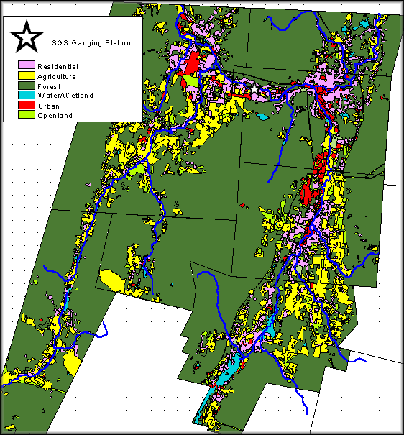
Figure 2. Land Use in the Upper Hoosic River Watershed (Data from MassGIS)

Proposed Project Location

This proposal focuses on a 2,400 ft. section of the Hoosic River at the confluence of its North and South Branches in North Adams (see Figure 3). It extends from the Marshall St. bridge past the confluence and to the end of the concrete chute (approximately 550 ft. west of Brown St). Figure 4 shows this location in 1875 (over eighty years prior to channelization), and Figure 5 is a current orthophoto of the site. The old Sprague Electric buildings (several of which are now occupied by the Massachusetts
Museum of Contemporary Art) were built directly adjacent to the south side of the North Branch of the Hoosic River. Several other Sprague Electric buildings occupy the southern side of the Main Stem of the Hoosic just downstream of the confluence. The north side, between the river and the River St. sidewalk, is primarily green space. With the construction of the Porches Inn on the north side of River St. at this site, the City of North Adams has been expanding this green area, having recently purchased and removed an automotive repair business (see figure 5). The city has also purchased land on the north side of River St. next to Marshall St. and is currently in the process of creating a park and parking lot in anticipation of an extension of the Ashuwillticook Bike Trail and the park planned for River St. A car wash and a seasonal pool supply business remain on the corner of Marshall St. and the south side of River St. Several buildings exist to the north of the river, between Brown St. and the end of the concrete chute. Bridges cross the river at Marshall St. and Brown St., and a gas main arches over the river at the confluence. Cabling is strung on a number of telephone poles through this area, but preliminary research suggests that no buried telephone, cable, power, or sanitary sewer exist to the north between the Hoosic River and River St.
Table 1 summarizes FEMA discharge estimates for Locations 1 and 2 (shown in Figure 5) of this site, as well as my calculations for each site. FEMA discharges were calculated based on 43 years of data from North and South Branch gauging stations, and

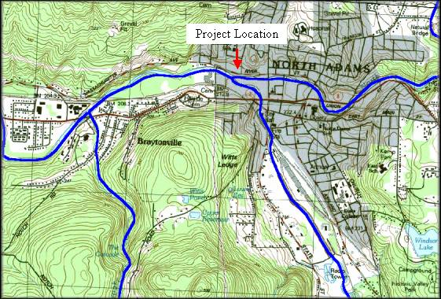
Figure 3. Project Location
34 years of data from a gauging station along the Mainstem. The time frame during which this data was collected was not specified. My calculation of discharge along the Mainstem is based on 61 years of data collected between 1941 and 2001 at USGS gauging station 01332500 (Hoosic River near Williamstown, MA). My calculation of discharge along the North Branch is based on 58 years of data collected between 1932 and 1989 at USGS gauging station 1332000 (North Branch Hoosic River at North Adams, MA). Both FEMA estimates and my own were obtained from a log-Pearson Type III distribution of the annual peak flow data. It is unclear why these estimates differ so significantly in magnitude. One possibility is that the more recent data reflect a reduction of peak flow due to changes in land use; percent forest cover in the watershed has increased dramatically over the past century. In any case, it is clear that flow data should be reanalyzed before using discharge estimates for particular recurrence intervals (e.g., the 100-year flood) for flood control planning.

Summary of Discharges
Flooding Source and Location | Drainage Area (sq. miles) | 10-year flood | 50-year flood | 100-year flood | 500-year flood
1) Mainstem (FEMA):  1) My calculation: | 115.8 | 7,208  7172 | 13,087  11,504 | 16,550  13,821 | 27,535  20,268
2) N. Branch (FEMA):  2) My calculation: | 41.7 | 4,990  4,921 | 9,250  8,128 | 11,800  9,812 | 19,900  15,063
Table 1. Summary of Discharges

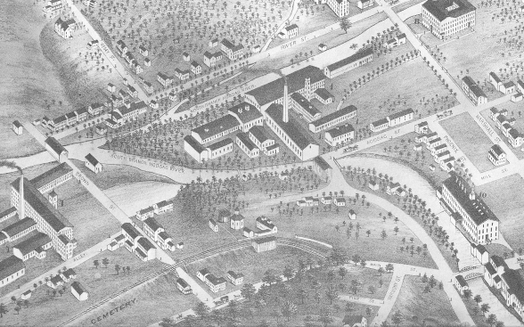

Figure 4. Project location as it appeared in 1875 (N. Adams Historical Society, 2000)
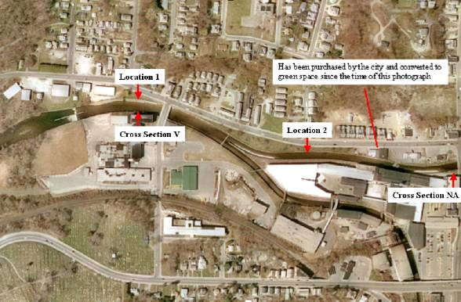
Figure 5. Orthophoto of project location (From MassGIS)

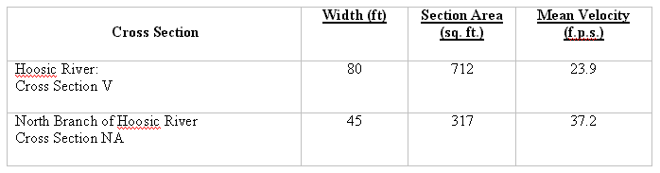

Table 2. FEMA Floodway Data

FEMA floodway data for this section of the river are shown above in Table 2. Cross Sections V and NA are shown in Figure 5. This data appears to be based on FEMA’s estimates of the 100-year flood.
Cross Sectional Analysis of the North Branch, using the original Army Corps of Engineers Federal Flood Control Project plans, was performed at Location 2, shown in Figure 5 above. Results are presented in Table 3 below. Width, height, and slope of the channel were obtained directly from Army Corps plans (Figure 6). Manning’s N was chosen for “ordinary concrete lining” as designated by the Federal Interagency Stream Restoration Working Group (2001). Manning’s equation was used to calculate velocity and discharge. This calculated discharge is nearly equal to FEMA’s calculation of the 500-year flood.
Width of Chute (ft)= 45 | R (ft)=A/P: 7.826087
Height of Chute (ft)= 12 | S= 0.0065
Perimeter (ft)= 69 | Velocity (ft/sec.)=(1.486/N)R^(2/3)S^(1/2): 36.3
Area (ft)= 540 | Discharge (cfs)=AV: 19616.5
N (concrete)= 0.013
Table 3. Cross Sectional Analysis of Location 2

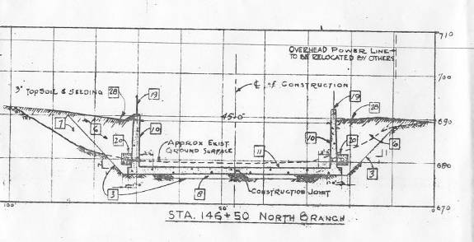
Figure 6. Cross Section at Location 2 (Army Corps of Engineers Flood Control Plans)

Field measurements were taken at a site approximately 3 miles downstream of the end of the concrete chute and compared with the Vermont Regional Hydraulic Geometry curves. The location chosen, though it had been slightly modified by the flood control project, more closely exhibited natural channel conditions. Sedimentation consistent with natural point-bar and meander processes suggested that the river had reached equilibrium (was neither aggrading nor degrading) at this location. These field measurements were taken to determine the utility of using regional hydraulic geometry relations to predict channel form. As seen below in Figure 7, field conditions were matched fairly well by predictions of regional curves, using the mean annual flood value as Q_{cf}. Because “natural” channel form slightly downstream of the channelized section of river matches the predictions of these regional curves, restoration planning in locations without channel morphology descriptions prior to channelization may benefit from using the Vermont Regional Hydraulic Geometry curves as a rough estimate of natural channel form. Appropriate stream width and depth in areas that are currently encased in concrete could be interpolated from these curves in designing a more natural flood control channel.

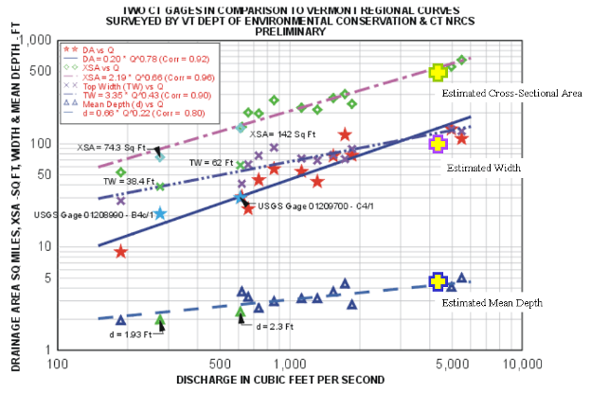
Figure 7. Comparison of Field Measurements with VT Regional Hydraulic Geometry Curves
(NRCS, 2003)
Recommendations

River St. Project Site
Improvements to the current state of the Hoosic River should focus on restoring aquatic habitat, improving public access and recreational uses of the river, while at the same time engineering for flood control. At the confluence of the North and South Branches of the Hoosic, Mass MoCA and other old Sprague Electric buildings are built in what had been the floodplain. Unless these buildings are removed at some point in the future, the retaining floodwalls abutting them will have to remain. To the north, between the river and River St., enough open space exists to remove parts of the floodwalls and restore a more natural floodplain, while still containing the 100-year flood within the newly-engineered channel.
Figure 8 shows how this could be accomplished. Floodwalls on the northern side of the channel would be removed along with approximately half of the concrete channel bottom. Large boulders would be used to form the shape of a more natural stream with low flow concentrated in its center. This designed channel (as shown in Figure 8) would be designed to carry the mean annual flood. By concentrating the flow, the river would remain passable for fish during periods of low flow. This substrate would provide a more natural aquatic habitat capable of supporting plants and macroinvertebrates.
Riparian vegetation would be placed on either side of the main channel. Where the floodwall remains, plants would help to cover the concrete, creating a more aesthetically pleasing stream. On the north side of the channel, a riparian edge would connect with an extended floodplain, designed for public use. For example, while this area is technically a park at the present time, it is almost never used. By restoring this section of the river, making it publicly accessible, and with the addition of picnic tables, swings, and/or a nature trail, this site would be transformed into an attractive recreation area. Mass MoCA could be invited to contribute art towards the creation of a sculpture garden. With the extension of the Ashuwillticook Rail Trail between North Adams and Williamstown, the bike trail could be linked with access to the river along River St. Kayak and canoe access to the Hoosic could be included in this plan. This floodplain between the river and River St. would be expected to flood on occasion. As shown in Figure 8, it would be designed to carry the 100-year flood.
Figures 9 and 10 show the current channel and the proposed channel design, and Figure 11 shows areas on River St. where enough space exists to expand the floodplain. One of these areas is entirely green space, while the other two contain several buildings. Two of these existing buildings are adjacent to land recently purchased by the City of North Adams and converted into open space. Purchasing these two buildings is therefore consistent with the City’s revitalization efforts for this section of North Adams.
While preliminary research suggests that these areas are free of buried cable, gas, and sanitary sewer pipes, above-ground cabling is strung through this area and would have to be relocated before expanding the floodplain. Because this project is adjacent to a Sprague Electric Brownfields site, sediments would have to be tested before excavation. Furthermore, all required permits would have to be obtained before any alterations are made to the existing structure.
In order to safely provide canoe and kayak access at this site, grade control structures downstream would have to be assessed and modified, if not removed altogether; drops greater than approximately 3-4 ft. would be dangerous for paddlers. Removing these structures would also promote fish passage and extend trout habitat, which is likely obstructed to a considerable degree by the current grading.

Application to the Wider Flood Control Project
It is recommended that a similar restoration model be applied throughout the extent of both flood control projects in Adams and North Adams. Where enough space exists on one or both sides of the river, one or both walls could be removed, and the channel designed to replicate a more natural stream while still containing the 100-year flood within the engineered floodplain(s), as described above. The City of North Adams and the Town of Adams should be encouraged to purchase property along the river that becomes vacant, with the aim of maximizing the extent to which natural stream conditions can be restored. This proposed plan allows both municipalities the flexibility to restore the ecological and recreational value of the Hoosic River section by section over time, as space and funding become available.
For sections of the river that are so constrained by development that space will probably never be available to expand the floodplain, a different strategy is needed. As discussed above, the concrete chute was engineered for the 500-year flood (which, also described above, may be considerably less than it was calculated to be in the past). There are several ways to improve aquatic habitat and recreational value in these constrained reaches of the river.
If the desired goal is to restore ecological function, the most important factors to address are cover, and channel bottom substrate and profile. One way to enhance this native trout habitat would be to line the channel bottom with boulders and cobbles in a manner that concentrates low flow. Each side of this reformed channel (engineered entirely within the existing channel) could be planted with riparian vegetation, which would provide the necessary cover. This model would effectively create a more natural channel entirely within the existing concrete channel. Because the current chute is large enough to contain the 500-year-flood, it is possible that a redesigned more natural channel capable of containing the 100-year flood could be created within the existing floodwalls.
If the primary goal of restoration is to improve recreational value, another innovative possibility exists. A new method of increasing public access and enjoyment of urban rivers consists of designing “playscape” paddle runs (see Figure 12). In this scenario, the flow is concentrated and whitewater conditions are created with the placement of small (2-3 ft.) grade drops for paddlers. As shown in Figure 12, such a project could incorporate areas for public access to the river contained within an area designed to carry the 100-year flood (artfully designed stepped floodwalls in the picture provide this measure of flood control without detracting from public enjoyment of the river). This design may be an attractive possibility for the constrained sections of the Hoosic River in North Adams and, properly designed, it may improve fish habitat at the same time as attracting paddlers and tourists. With this region’s emerging image as a tourist destination for the arts and recreation, development of a section of the Hoosic River into an urban paddle run is an interesting option. Mass MoCA and/or the Contemporary Artists Center might be interested in collaborating on a design, and plans to extend the Ashuwillticook Rail Trail could include connectivity with the project.
Another relatively quick and inexpensive option of habitat improvement should be considered for the areas of the flood control project consisting of rip-rap levees. Currently, the Operations and Maintenance Protocols defined by the Army Corps of Engineers require the City of North Adams and the Town of Adams to mow the sides and tops of the levees and remove vegetation growing in the rip-rap in order to maintain the stability of these structures. The river flowing through these sections of the flood control projects is even less shaded than the areas where it flows through the concrete channels. While the lack of vegetation detracts from the aesthetics of a “natural” stream, the increased exposure to sunlight causes an increase and greater variability of stream temperature, which adversely impacts trout. The possibility of planting vegetation that will not interfere with the structural integrity of the levee structures (or simply allowing the vegetation that continues to sprout through the rip-rap) should be investigated.
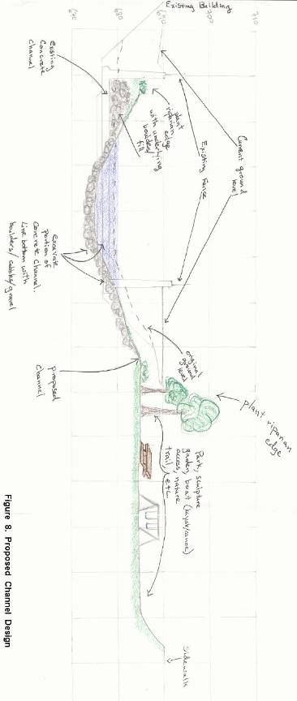
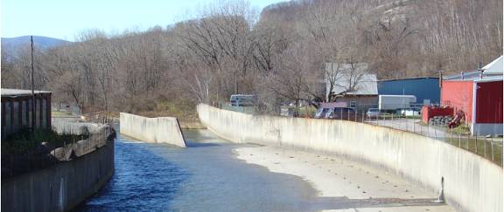
Figure 9. Current Channel

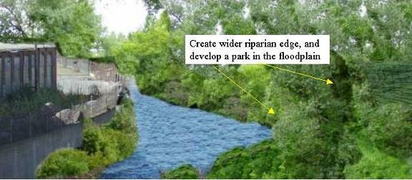
Figure 10. Proposed Channel

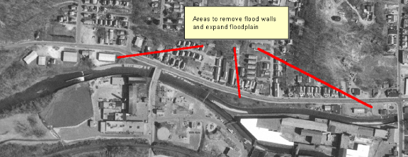
Figure 11. Areas to expand Hoosic River floodplain

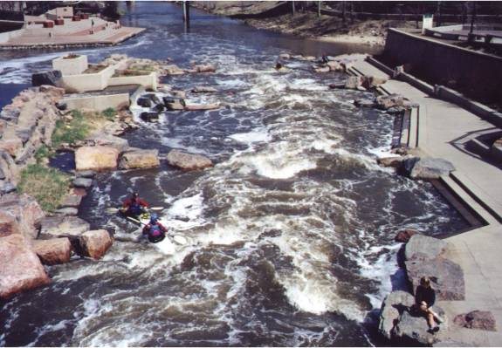
Figure 12. Urban paddle run (Courtesy Jim MacBroom, P.E.)
Conclusion

The Hoosic River is reemerging as one of North Berkshire’s greatest natural resources. North Adams is inching forward with plans to develop a park adjacent to the Hoosic River and connected to a proposed future site of the Ashuwillticook bike path. At the same time, the Hoosic River floodwalls at this site are already in need of repair (where a wall has fallen into the channel), and such repairs will only increase as the flood control projects continue to age. Incorporating a plan to increase public access to the river and to improve the river’s ecological function should be considered as North Adams moves forward with the revitalization of River Street and the creation of this park.
A restoration project is currently being planned to enhance trout habitat and increase public access to the Hoosic River in downtown Adams. This restoration has been incorporated into the Adams Downtown Development Plan. North Adams will soon need to decide whether or not to take advantage of the recreational and ecological value that, with some planning and creativity, could be restored to the Hoosic River. This proposal presents a way that this historic river could be restored to more natural and publicly valuable conditions over time, through a number of independent projects of manageable size. These projects could be designed separately with consideration given to the different constraints present in different reaches of the river. The possibility of revegetating the rip rapped levees should be investigated in both Adams and North Adams. Where enough space exists on one or both sides of the river, the channel could be redesigned to closely match natural conditions. The towns may decide to purchase property abutting the floodwalls to expand the length of the river that could be reengineered in this fashion. Where development constrains any floodplain expansion, it will be necessary to identify restoration goals. To restore aquatic habitat, a more natural channel could be engineered within the current chute. To promote recreation and public use of the river, consideration should be given to the construction of an artfully designed, urban paddle course. Whatever priorities are agreed upon, this is an exciting and realistic opportunity for the City of North Adams and the North Berkshire region to reclaim the ecological and recreational value of its historic Hoosic River.

References

Berkshire Regional Planning Commission. Hoosic River Action Plan: Draft Report. 1986

Federal Emergency Management Agency. Flood Insurance Study: City of North Adams, Massachusetts, Berkshire County. 1981.

The Federal Interagency Stream Restoration Working Group. Stream Corridor Restoration: Principles, Processes, and Practices. USDA-Natural Resources Conservation Service. Published October, 1998, Revised August, 2001. http://www.usda.gov/stream_restoration

Hansen, Bruce P., Gay, Frederick B., and Toler, L. G. Massachusetts Hydrologic-Data Report No. 15: Hydrologic Data of the Hoosic River Basin, Massachusetts. United States Department of the Interior Geological Survey. 1974.

Kennedy, Laurie E. and Weinstein, Mollie J. Hudson River Basin: 1997 Water Quality Assessment Report. Massachusetts Department of Environmental Protection. 2000.

Massachusetts Executive Office of Environmental Affairs. Massachusetts Geographic
Information System. 9 Dec. 2003. 11 Dec. 2003
http://www.state.ma.us/mgis/massgis.htm

Natural Resources Conservation Service. New England Upland Section Regional Curves. 29, Jul. 2003. 14 Dec. 2003.
http://wmc.ar.nrcs.usda.gov/technical/images/ne-regm-crv.gif

North Adams Historical Society. North Adams in 1875: 125 Year Anniversary Map.
2000.

U.S. Census Bureau. Massachusetts County Selection Map. 15 Jul. 2003. 11 Dec. 2003.
http://quickfacts.census.gov/qfd/maps/massachusetts_map.html

